**Experiment - 1**

**Student Name: Vivek Kumar UID: 21BCS8129**

**Branch: BE-CSE(LEET) Section/Group: WM-20BCS-616/A**

**Semester: 5th Date of Performance: 16/08/2022**

**Subject Name: Machine Learning Lab Subject Code: 20CSP-317**

**1. Aim/Overview of the practical:**

Create an application to save the employee information using arrays.

**2. Task to be done/ Which logistics used:**

Write the program to create an application to save the employee information using arrays.

**3. Algorithm/Flowchart (For programming-based labs):**

**4. Steps for experiment/practical/Code:**

import java.io.BufferedReader;

import java.io.IOException;

import java.io.InputStreamReader;

public class Employee {

String empId;

String depName;

String empDesignation;

String empName;

String dateJoin;

int basic;

int hra;

int it;

char designationCode;

public static int da;

public Employee(

String empId,

String depName,

String empDesignation,

String empName,

String dateJoin,

int basic,

int hra,

int it,

char designationCode

) {

this.empId = empId;

this.depName = depName;

this.empDesignation = empDesignation;

this.empName = empName;

this.dateJoin = dateJoin;

this.basic = basic;

this.hra = hra;

this.it = it;

this.designationCode = designationCode;

}

public static int da(char designationCode) {

switch (designationCode) {

case 'e':

{

da = 20000;

break;

}

case 'c':

{

da = 32000;

break;

}

case 'k':

{

da = 12000;

break;

}

case 'r':

{

da = 15000;

break;

}

case 'm':

{

da = 40000;

break;

}

default:

throw new IllegalStateException("Unexpected value: " + designationCode);

}

return da;

}

public static int salary(int basic, int hra, int da, int it) {

int salary = basic + hra + da - it;

return salary;

}

public static void details(

String empId,

String empName,

String depName,

String empDesignation,

int salary

) {

System.out.println(

"Emp Id\t\tEmployee Name\tDepartment\t\tDesignation\t\tSalary"

);

System.out.println(

empId+"\t\t"+empName+"\t\t"+depName+"\t\t\t"+empDesignation+"\t\t"+salary );

}

public static void main(String[] args) throws IOException {

BufferedReader bufferedReader = new BufferedReader(

new InputStreamReader(System.in)

);

String empId;

int c = 0;

Employee[] employees = new Employee[3];

employees[0] =

new Employee("1001","R&D","Engineer","Ash","1/04/2009",20000,8000,3000,'e');

employees[1] =

new Employee("1002","PM","Consultant","Anjali","23/08/2012",30000, 12000, 9000,'c');

employees[2] =

new Employee("1003","Acct","Clerk","Raju","12/11/2008",10000,8000,1000,'k');

System.out.println("Enter the employee ID ");

empId = bufferedReader.readLine();

for (int i = 0; i < 3; i++) {

if (employees[i].empId.equals(empId)) {

c = 1;

int salary = salary(

employees[i].basic,

employees[i].hra,

da(employees[i].designationCode),

employees[i].designationCode

);

details(

employees[i].empId,

employees[i].empName,

employees[i].depName,

employees[i].empDesignation,

salary

);

break;

}

}

if (c != 1) System.out.println("Entered employee ID not found");

}

}

**5. Observations/Discussions/ Complexity Analysis:**

Here we have created the Array with the size of 3 and Data inserted and Give the Search method with Employee

**6. Result/Output/Writing Summary:**

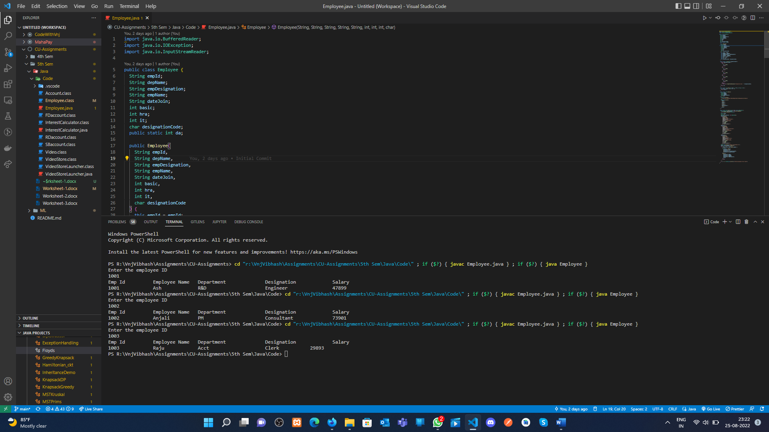

**Learning outcomes (What I have learnt):**

**1.** Learn How to create the array.

**2.** Array manipulation in java.

**Evaluation Grid (To be created as per the SOP and Assessment guidelines by the faculty):**

|  |  |  |  |
| --- | --- | --- | --- |
| Sr. No. | Parameters | Marks Obtained | Maximum Marks |
| 1. |  |  |  |
| 2. |  |  |  |
| 3. |  |  |  |
|  |  |  |  |